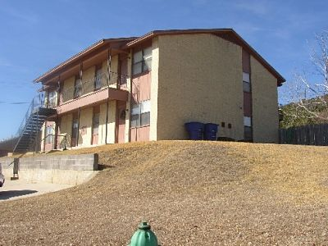
Comfortable Two Bedroom in Copperas Cove
This apartment, which is available for immediate occupancy, is located in a quiet residential area of town. It is in, what is considered to be, the best school district in the Fort Hood area. Walking distance to shopping. Be on post at Fort Hood in minutes without encountering a single traffic light. Pets are limited to cocker spaniel size and smaller and a one-time $300 pet fee is required per pet. The Security Deposit is $300. This is an all-electric apartment and you would be responsible for a water and an electricity bill. It comes with all kitchen appliances, including a DISHWASHER. Any other questions, please call 254-698-4824. The apartment is available for immediate occupancy. Or visit our web site at craftsmenproperties.com to view other vacancies and to download and submit a
FREE APPLICATION

PAGE DOWN TO SEE PICTURES
