**How About a Two-Bedroom Townhouse in Copperas Cove**

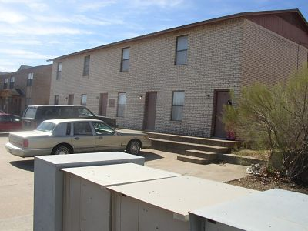

**This townhouse apartment is located in a quiet residential area of town. Live downstairs and sleep upstairs. No upstairs or downstairs neighbors to bother you. The apartment has all kitchen appliances (including a DISHWASHER), washer/dryer connections, and a bath and a half. The security deposit is $300. Small pets are permitted with a one-time $300 pet fee. To see other available apartments, or to download and submit a FREE APPLICATION, go to craftsmnproperties.com. The apartment is available for immediate occupancy. Any other questions, please call 254-698-4824.**

**Page Down to See More Pictures**

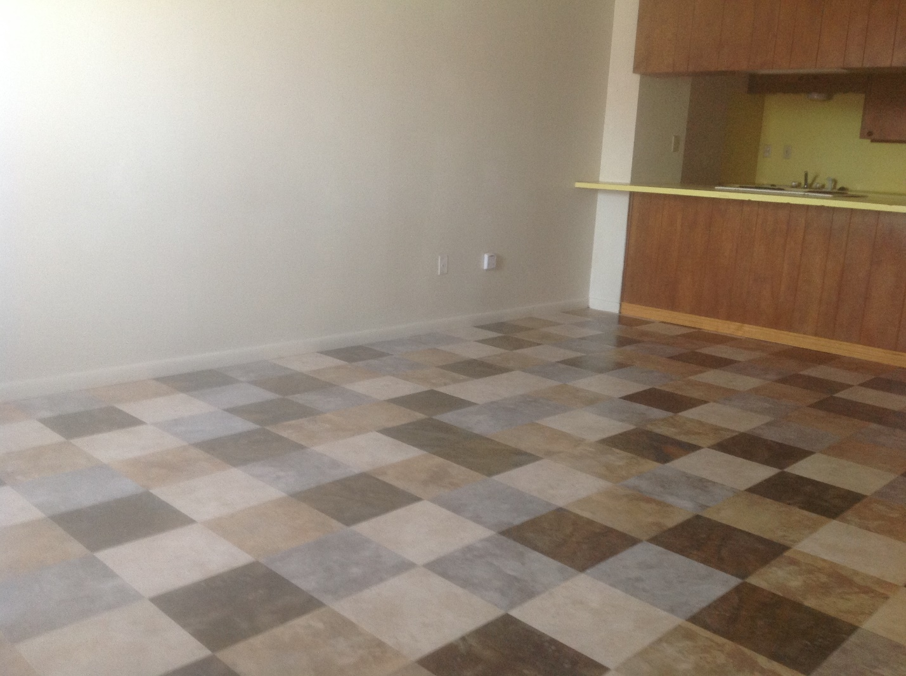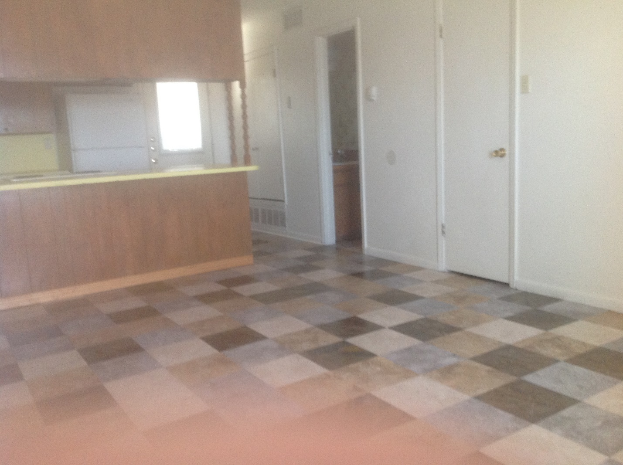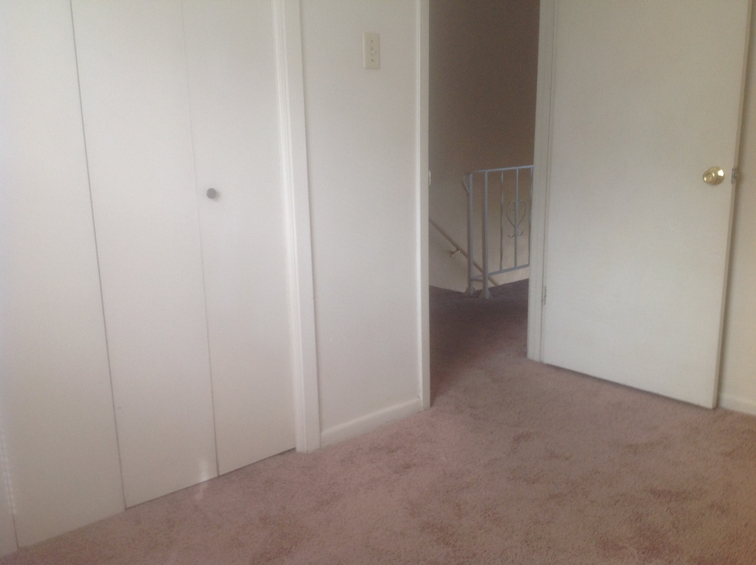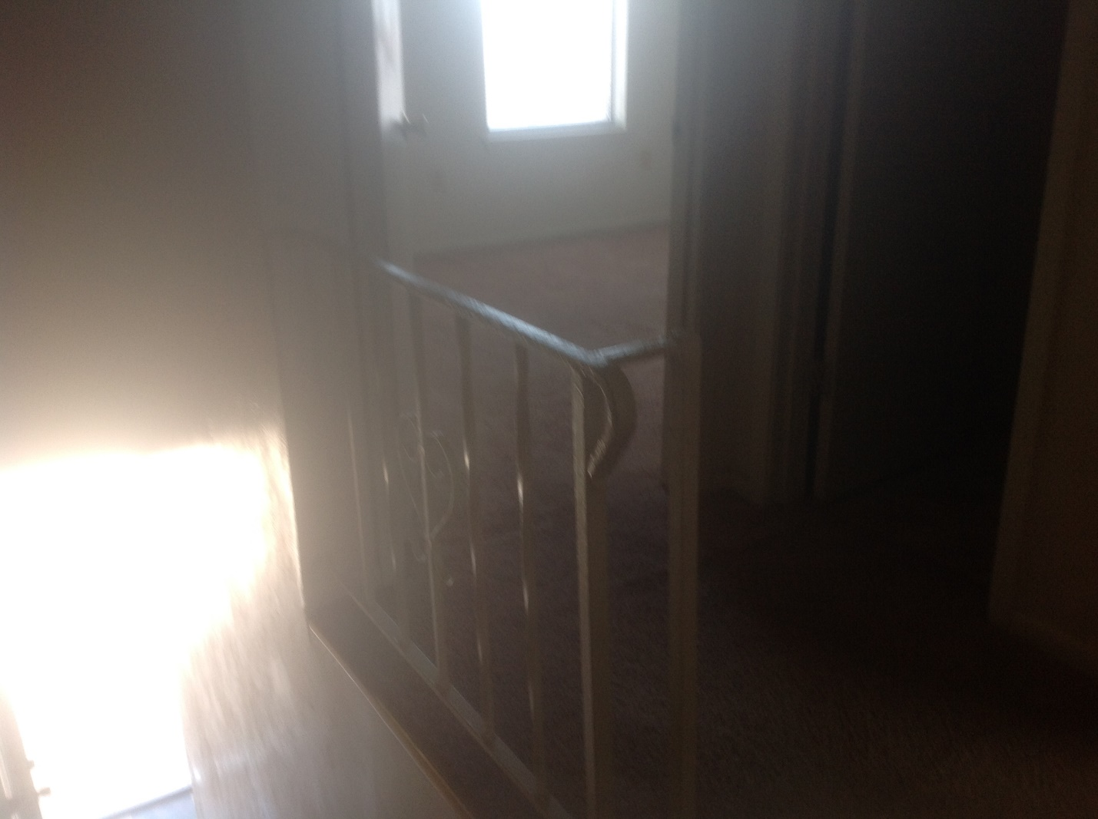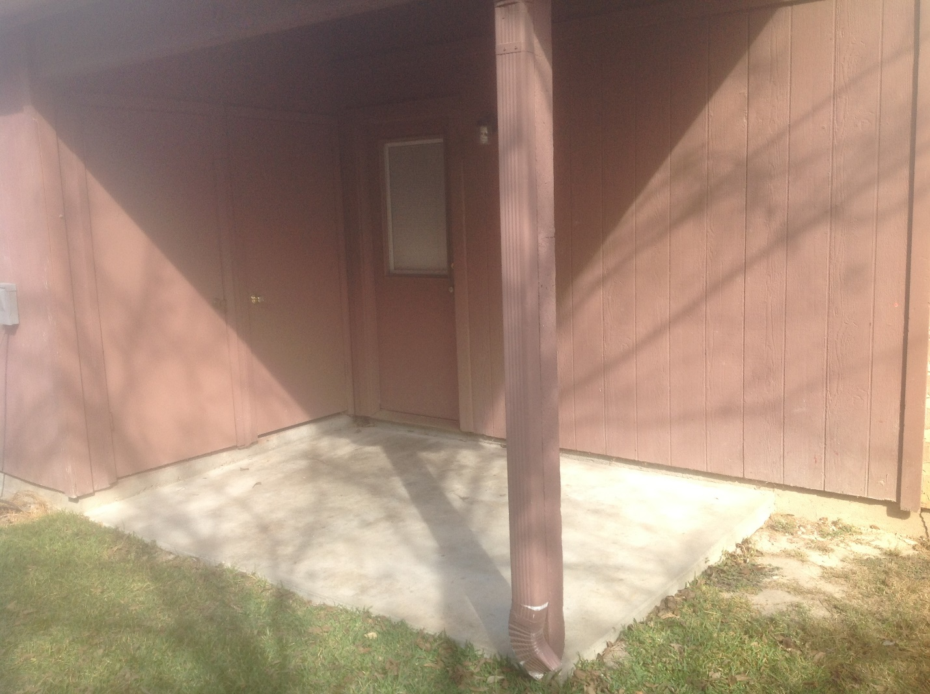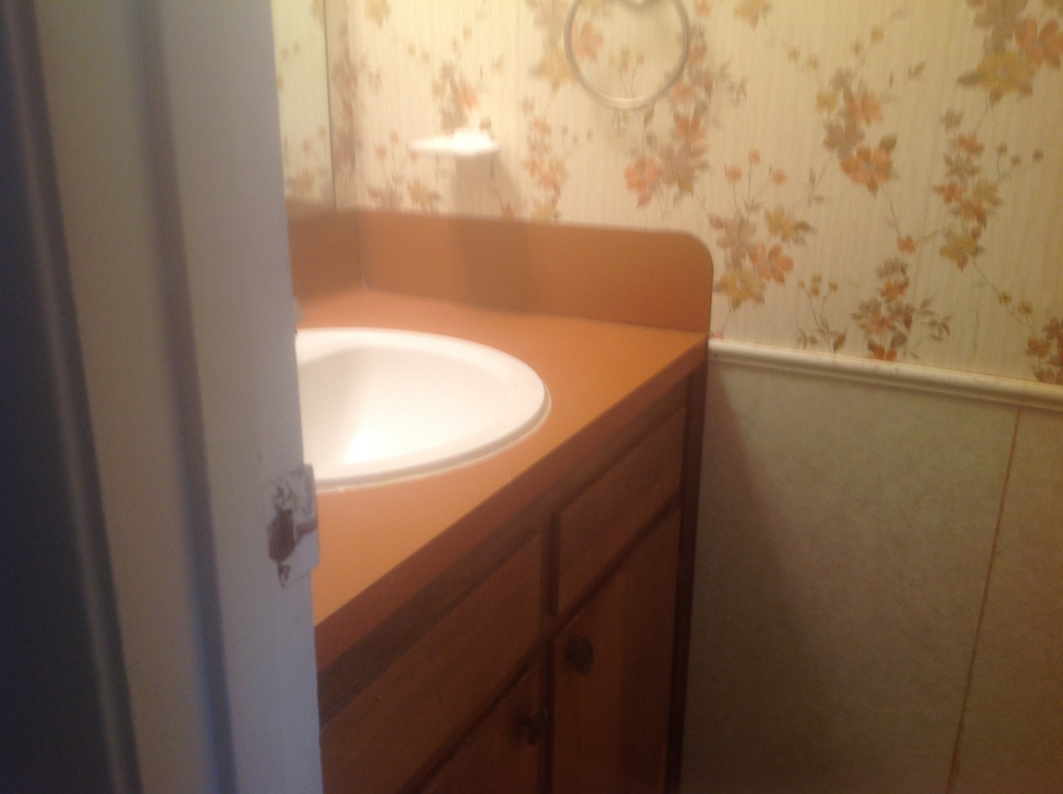web site 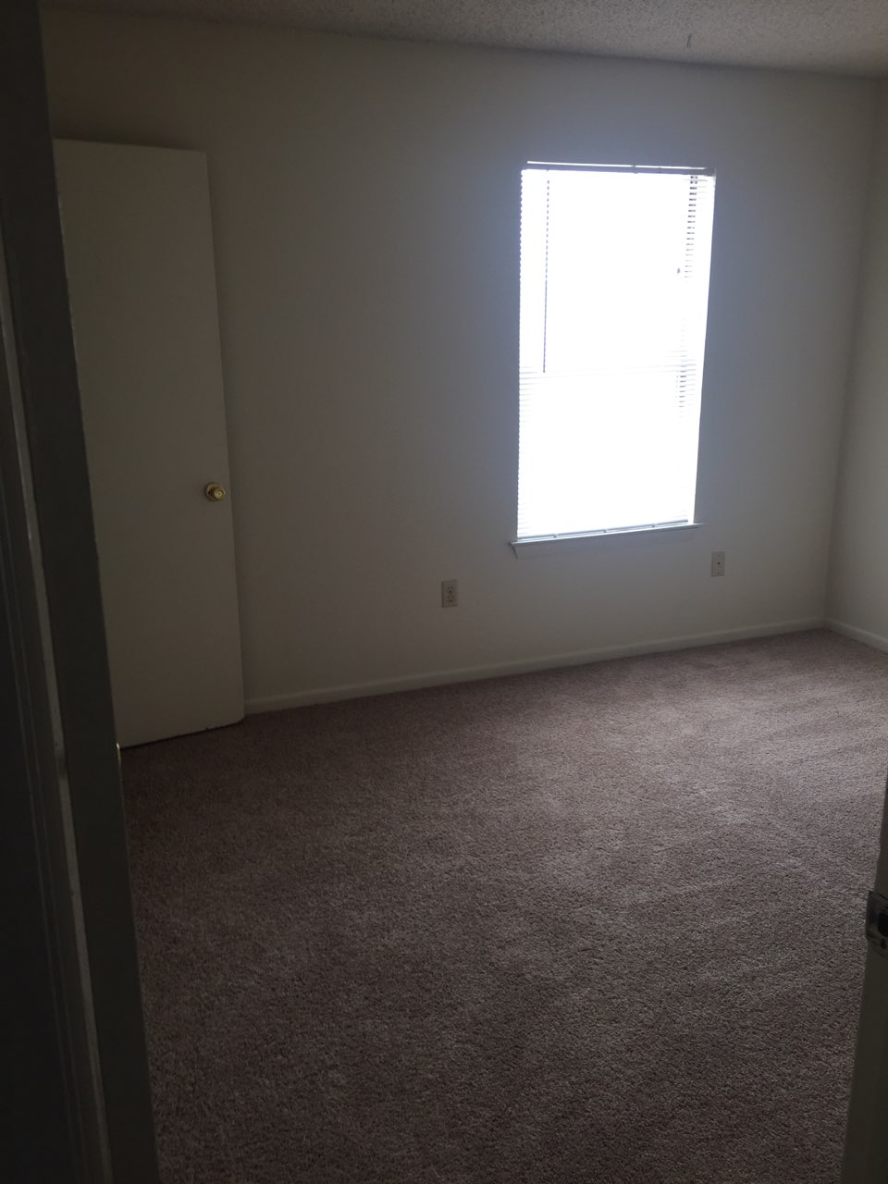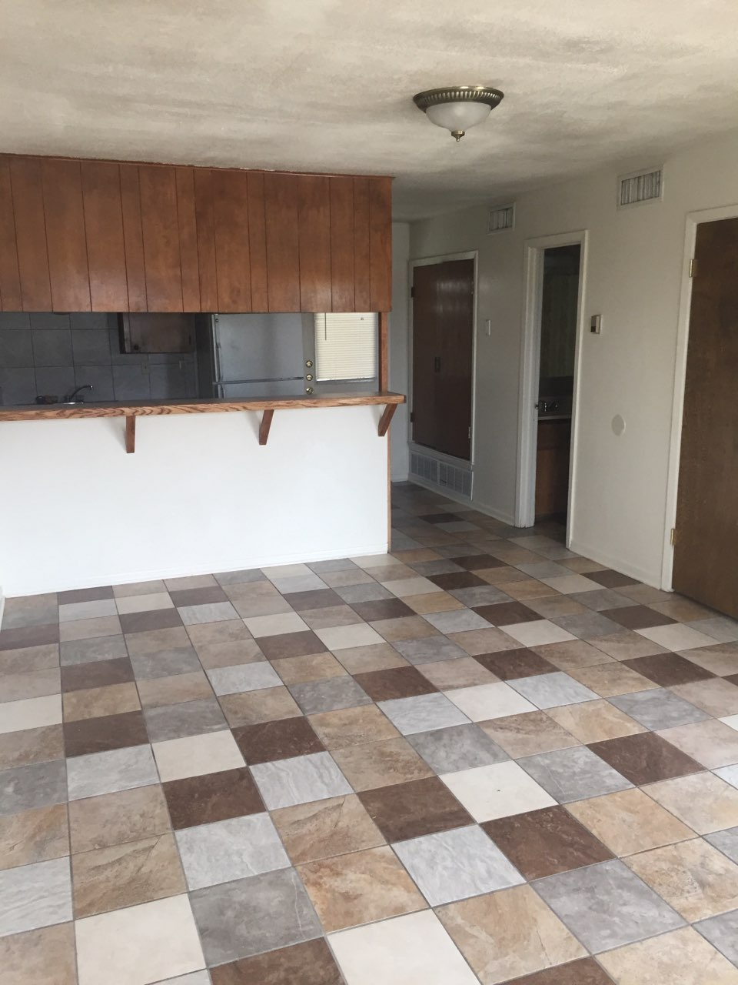at c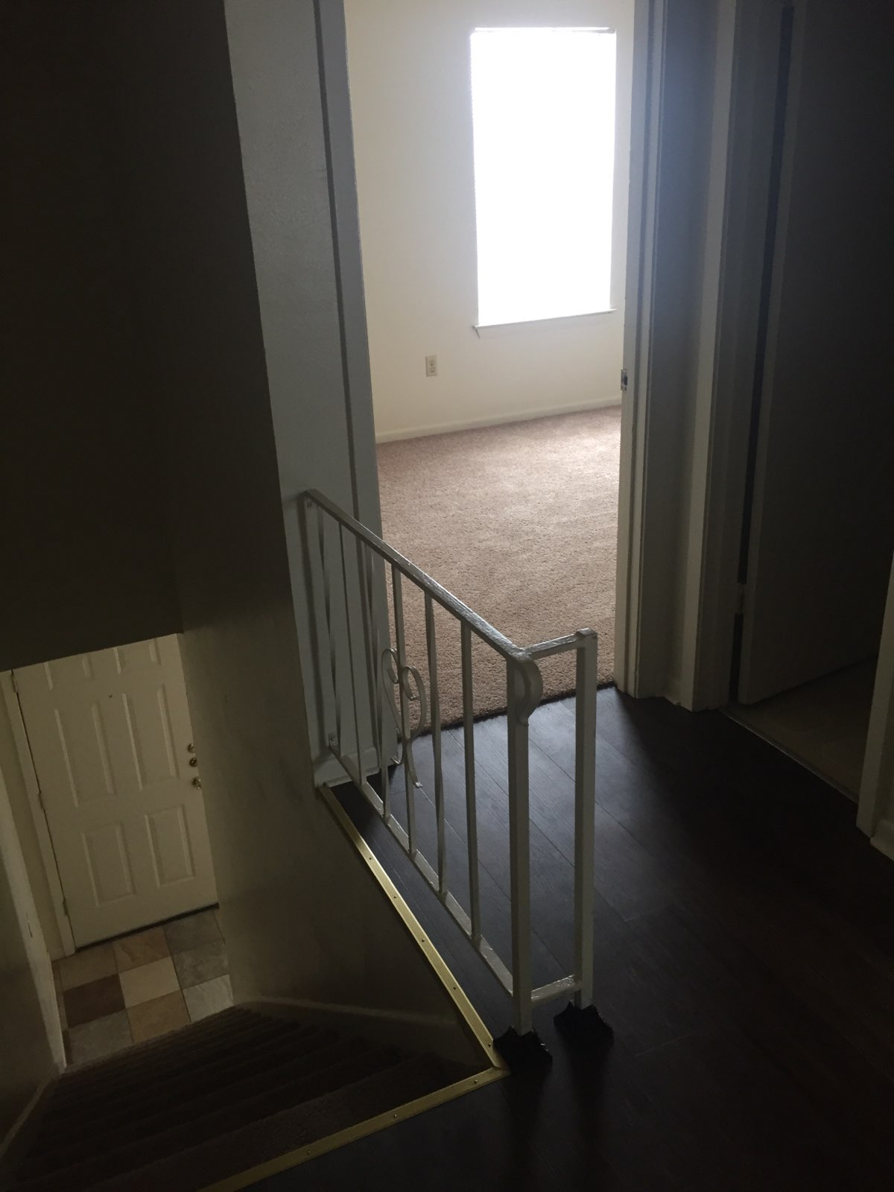r