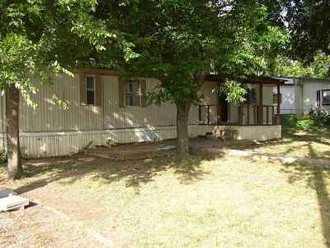

How About a Two Bedroom Home on Large Fenced Lot
This two-bedroom, one bath manufactured home is situated on a large fenced residential lot in Harker Heights. Pets are limited to no more than two pets, no larger than 20 pounds each fully grown and a $300 per pet fee is required per pet. Washer/Dryer connections and a storage building in the backyard. If you are interested in leasing this property or would like to see what other properties we have available to lease, please call 254-698-4824 or visit our web site at craftsmenproperties.com to download and submit a
FREE APPLICATION

Page Down to View Pictures

